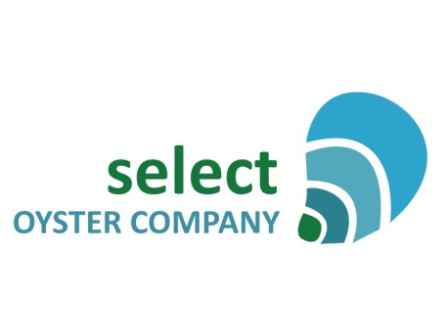

Sydney Rock Oyster Breeding Program Internship

Position Description

The Sydney Rock Oyster breeding program is a budding, highly sophisticated and hugely important technology which is a key priority for the strategy and sustainable future of the oyster aquaculture industry in NSW. We are seeking a passionate, energetic student or someone looking for a career change. The overarching aim of internship is to develop a skills base in Sydney Rock Oyster broodstock management. This program will ensure you gain valuable experience in the selective breeding program for the oyster aquaculture industry.

You will gain on-the-ground knowledge of the single pair mating family breeding program and broodstock repository system including: data collection in performance trials for fast growth and disease resistance, selection decisions based on pedigree analyses, managing genetic integrity across several families and year classes of oysters, oyster farming techniques, biosecurity protocols, hatchery production processes, the oyster industry, NSW government regulations and industry extension initiatives.

Your main role will be to provide technical field support to our Operations Manager in the maintenance of our growing repository of selectively bred Sydney Rock Oyster broodstock throughout coastal New South Wales. You will be required to commit at least three days every two months for field work on oyster leases in estuaries spaning NSW coastline from Yamba to Merimbula. Occasionally there may be other field work for a day or two planed with short notice which you will be invited to assist, but it will not be a requirement. The schedule is somewhat flexible, and it will be important you communicate regularly with SOCo to facilitate a timely and effective schedule. You may also be required to work in oyster hatcheries in Port Stephens and Laurieton, to assist in some of the technical operations of a Sydney Rock Oyster run. Your assistance in the hatcheries will depend on the hatchery schedule and your availability. The role is a six month program aiming to start in February 2017, with the possibility to extend.

We are looking for someone who:
- Loves working outdoors and demonstrates a strong understanding of what it means to work in the elements.
- Is highly organised and can manage logistics of field work including spending days away from home comfortably, and oftentimes interrupted schedules and last minute changes.
- Is passionate about aquaculture, fisheries and rural industries.
- Has plans to pursue a future in aquaculture and wants to learn through experience.
- Is logical, can think on their feet, shows initiative, and demonstrates they learn quickly to take on work with little instruction.
- Is happy to do physical work such as lifting oyster trays, being on punts, shifting large volumes of water.
- Is a people person: someone who enjoys spending time with others in the field, on oyster farms and in the car.
Selection criteria
- Extensive experience in coastal marine field work in technical and research capacities
- Final year university student, or recent graduate, or equivalent level of training or vocational background (i.e. TAFE, previous roles) from marine/environmental science or a related field
- Knowledge of bivalve aquaculture industries primarily in NSW and understanding of aquaculture management techniques such as selective breeding, farm management, and extension strategies
- Strong communication skills, including written, verbal and presentation experience
- Exceptional skills in MS Excel
- Current Australian drivers licence, or licence that permits you to drive in Australia
- Demonstrable knowledge of WHS procedures and policies
- Boat licence preferable but not essential

About the Company

Select Oyster Company P/L (SOCo) is the industry owned body that commercialises selectively bred Sydney Rock Oysters Saccostrea glomerata. We partner with NSW DPI Fisheries, our operational breeder in R&D of the selected lines of broodstock, and maintain working relationships with the oyster aquaculture industry, research institutes, extension groups and funding bodies. SOCo is administered by NSW Farmers Association, employs an Operations Manager, and is directed by a volunteer Board of oyster farmers and scientists.

The Sydney Rock Oyster breeding program started and lead by NSW DPI Fisheries for over 25 years has seen significant gains in oyster disease resistance, growth and performance. The industry is benefiting from these improved lines through seed supply by commercial hatcheries. It is SOCo that manages commercial broodstock and supplies it to hatcheries for seed production.

Demand for selected Sydney Rock Oyster seed outweighs supply, and demand is growing. The interest in hatchery development and expansion across several states is increasing. As such, a viable Sydney Rock Oyster hatchery capacity will supply oyster seed to perpetuate selected lines, mitigate the impact of unprecedented stock losses, and fuel a “smart state” service to industry, capable of driving farm profitability, increasing rural employment opportunities and harnessing a new and diverse level of technical skills and networks.

To apply
This is a non-paid internship; however your travel expenses will be covered. Please send a copy of your C.V and a cover letter which outlines how you meet the selection criteria, which is no longer than two pages. Email your application to selectoysterco@gmail.com, closing date February 16th 2017. Please direct enquiries to Emma Wilkie 0402 677 534.

